# Employee Management System

* The main login page has a nav-bar, consisting of
* Login
* Calendar
* Work Submission and
* Project statics.

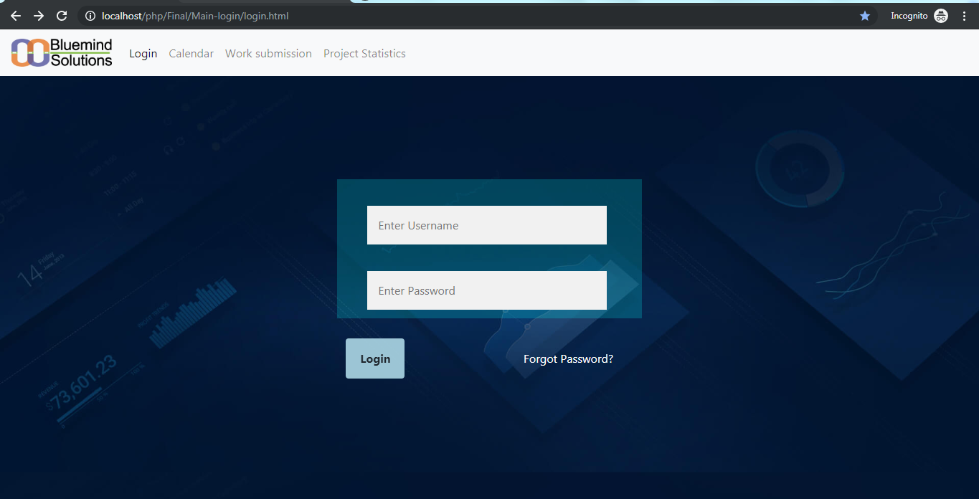

View of a main page

# Login page

Login page is designed such that if the username is given as ‘admin’ and the correct password then the page will be redirected to the admin portal.

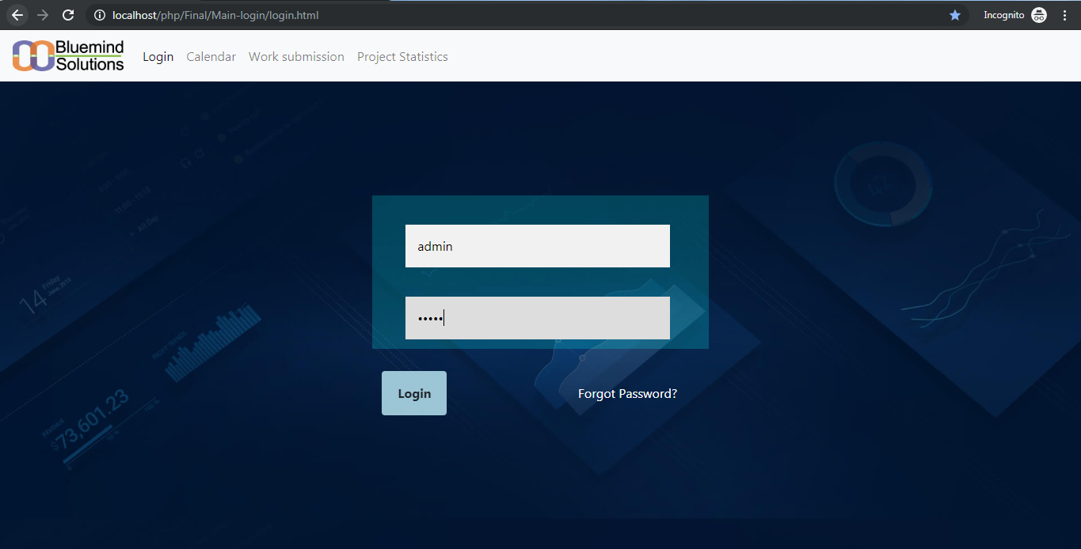

Admin-login

Suppose the user is employee than username and password to the employee is set by the admin. When the employee uses his username and password then the page will be redirected to the User portal.

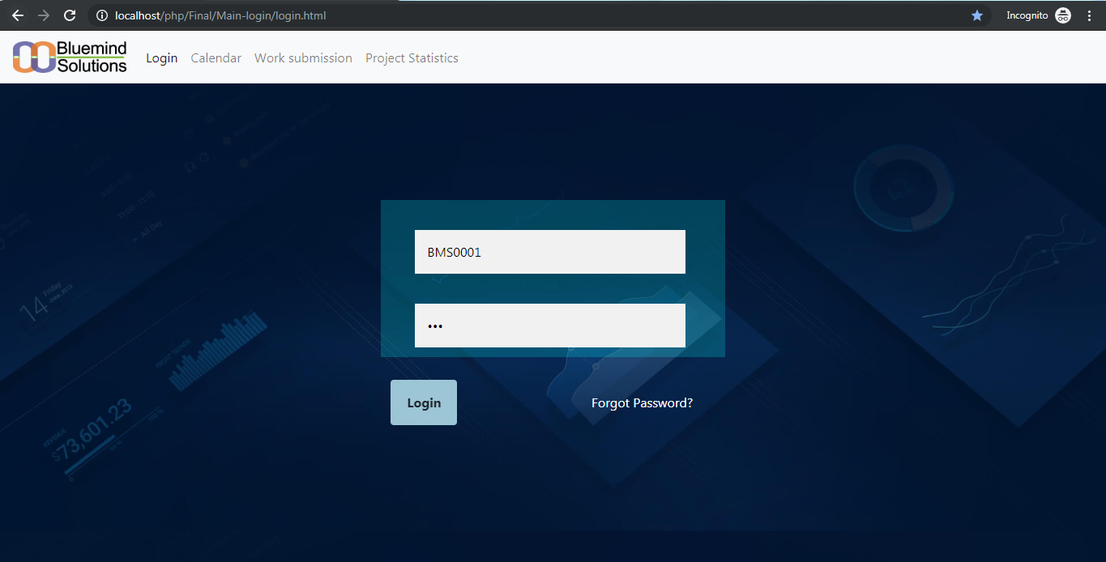

User-login

# Admin portal

The admin portal has the features to

* View Dashboard
* Add employee and manage employees
* Leave management system
* Update calendar( list of holidays)
* Project details
* Change admin password and
* Sign out

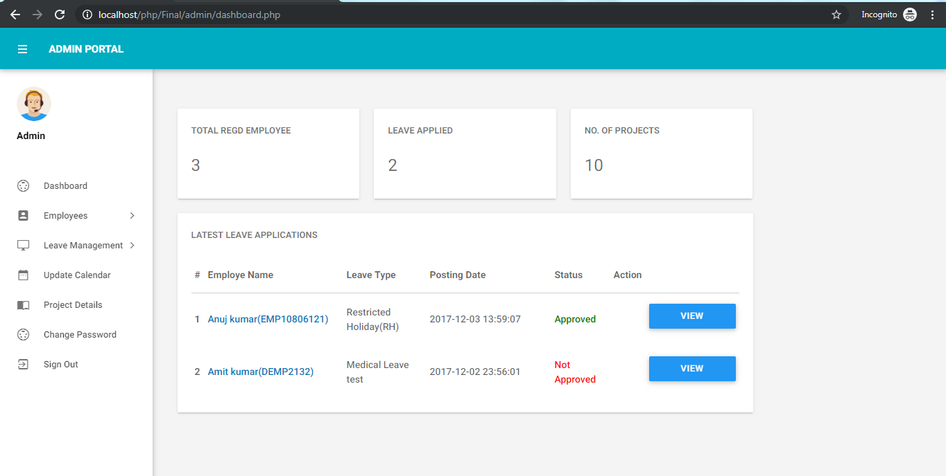

Admin-portal

## Dashboard

The dashboard gives the brief idea about

* the total no of the employees registered
* no of the people who have applied the leaves
* Number of ongoing projects
* And the list of people who have applied for leave. There is a provision to the admin to take action on whether to approve not approve the leave application. This status will be reflected back on the dashboard.

## Employee

Employee sidebar has two features that is one to create an employee and the other to manage the employee.

* **Create employee**

This feature enables the admin to give a Unique BMSID it also checks the database weather the ID is already in use. Admin enters the first name, last name and “**Password**” from which the employee can login. Admin can select to which department the employee belongs to.

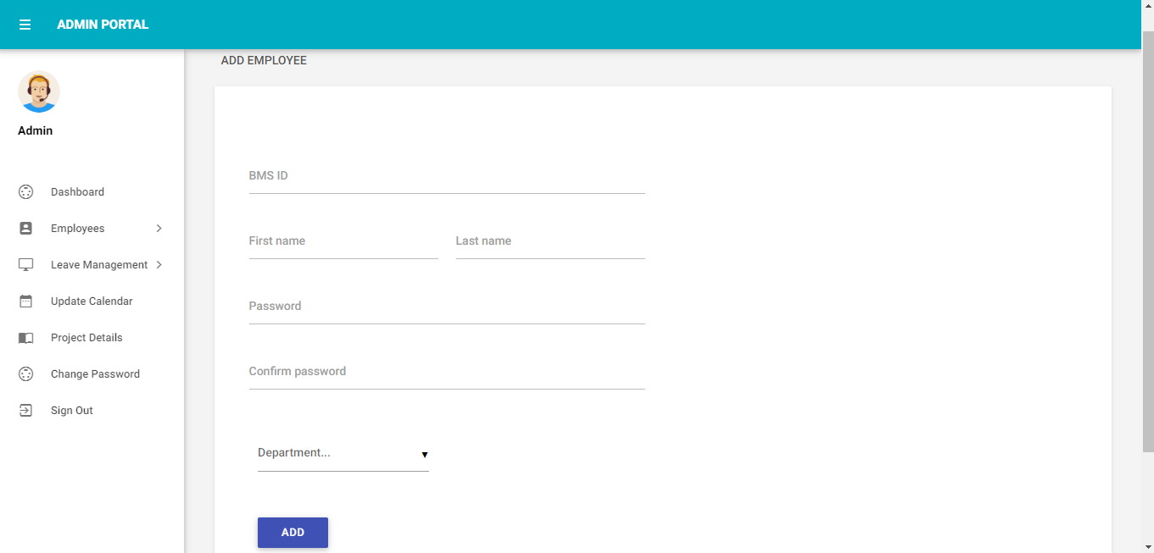

* **Manage employee**

This feature gives the brief information of the list of all the employees about BMSID, Full name, Department and an action either to edit employee or to delete the employee.

Using the edit employee the admin can update few of the details of the employee in the database.

Delete employee deletes all the information stored about the employee from the database.

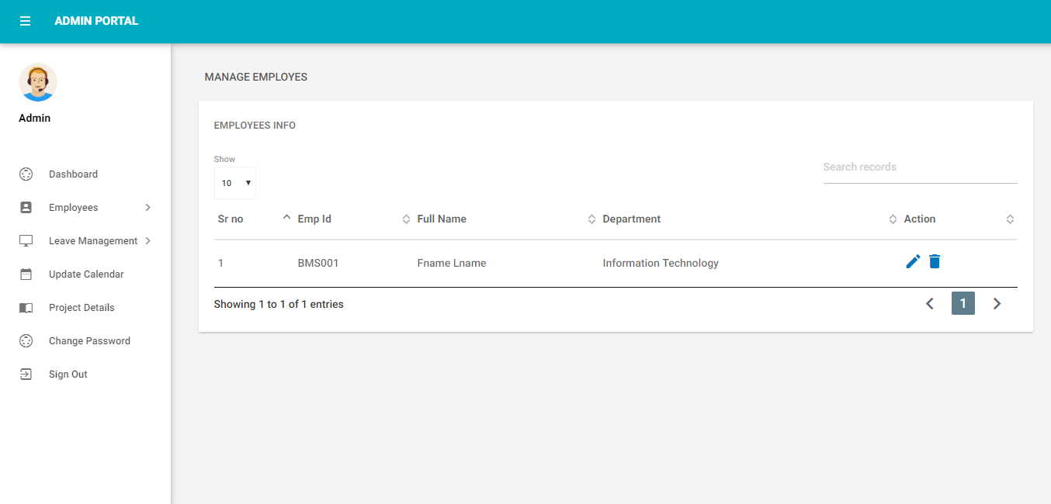

## Leave management

Initially the leave management gives the admin a brief about the employee name, leave reason, leave posting date, status and action button to view details and to take action to approve or disapprove the leave.

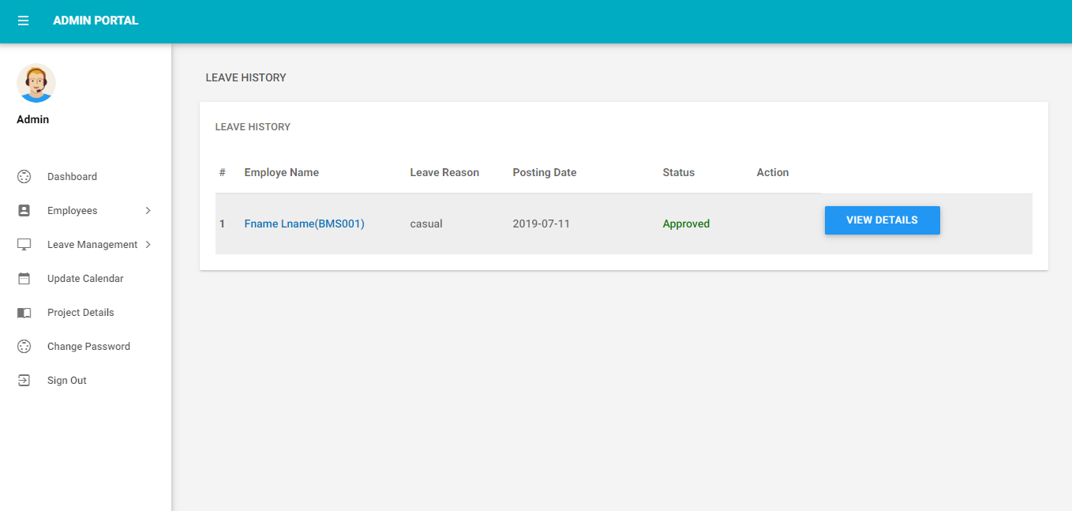

## Update calendar

This gives the admin the privilege to update the list of holidays in the calendar every year or to make any changes in the list of holidays.

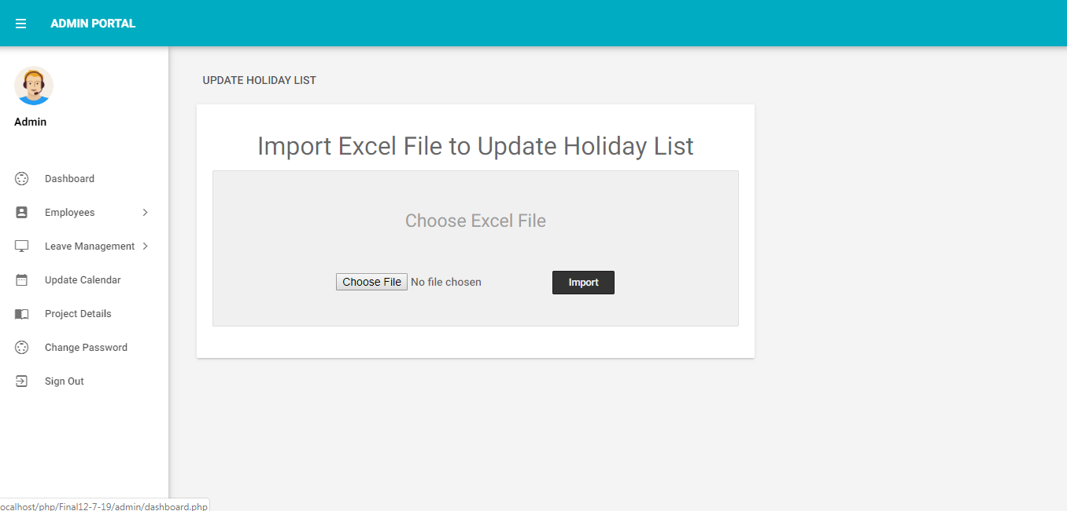

## Project details

Project details gives the detailed information about the projects with the project name, description, project start date, project end date, NO of days taken, progress %, remaining %.

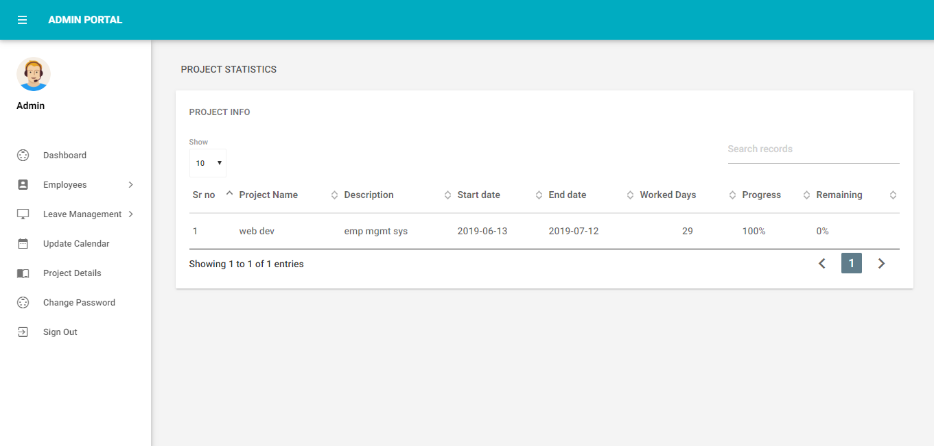

## Change password

This feature is only for admin to change his password for security reasons.

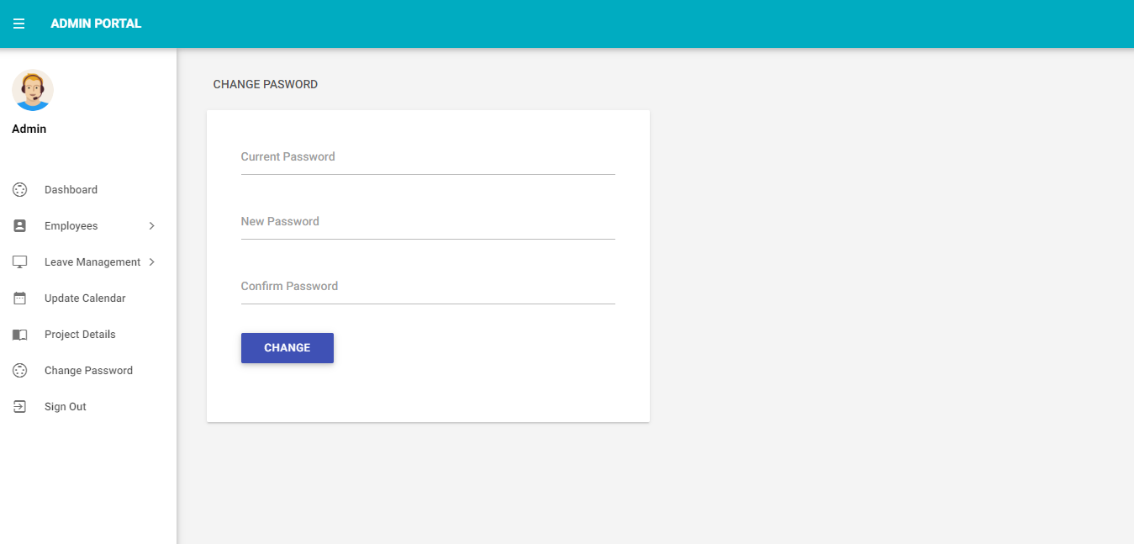

## Sign out

This closes the admin session and redirects him back to the login page.

The employee portal has the features to

# User portal (Employee portal)

The employee portal has the features to

* Update personal details
* Update contact details
* Update Experience details
* Upload Documents
* To send Leave Request to the admin
* Profile setting
* Feedback and
* To Sign out

# Updating personal details

This portal gives the provision to update employee’s personal details such as

* Full name
* Date of birth
* Gender
* Education

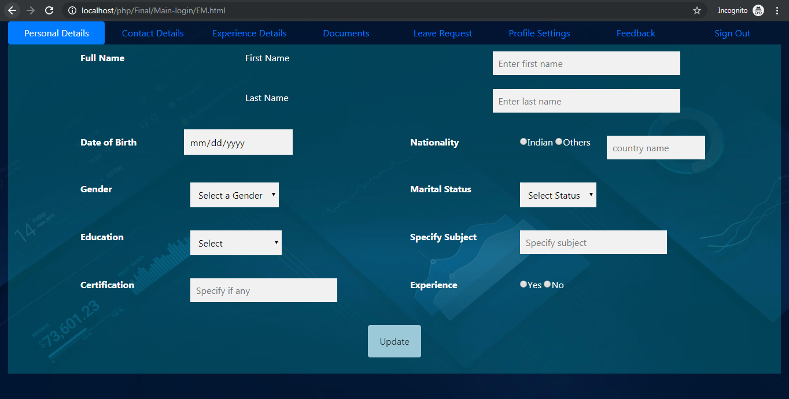

Personal details-portal

# Updating employees contact details

This portal is used to update the employees contact details such as

* Home phone number
* Emergency contact number
* Mobile number
* Permanent address
* Email Id

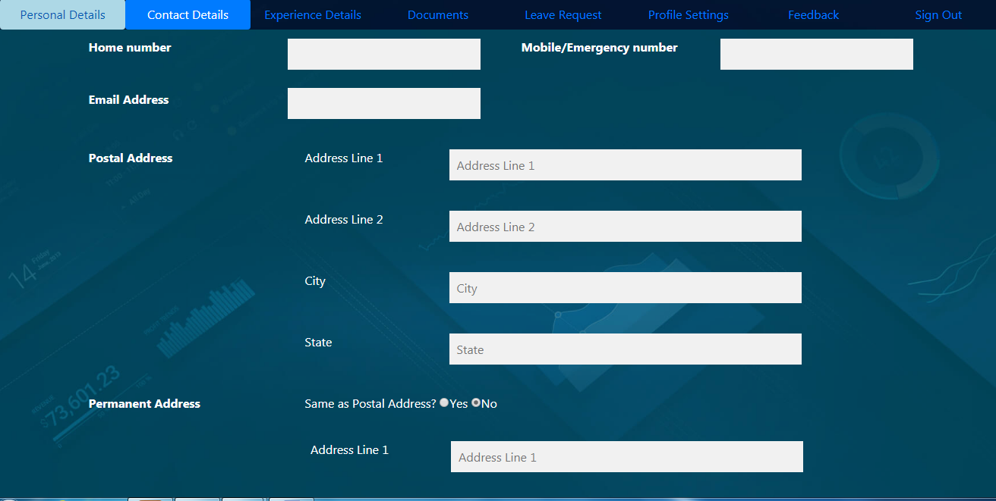

Personal details portal

# Updating previous work experience (if any)

This portal is provide to update any previous work experiences such as

* Previously worked company name
* Date of joining
* Date of reliving
* Designation
* Reason for leaving the company

# ed.PNG

Experience details portal

# Updating profile setting

This portal used for storing the some question which could be used for user authentication when user tries to reset his password in case if he forgets his password. stored details are

* 2 secret questions such as
  + - Vehicle number
    - SSLC marks
    - Pet name
* Profile link (if any)

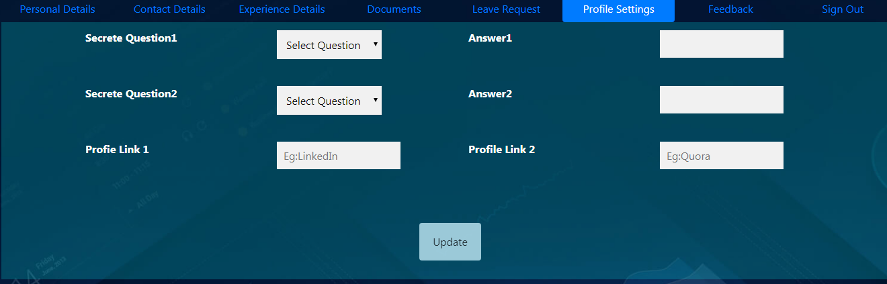

Profile setting portal

# Leave request application

This portal is used for applying for the leave online. Details collected are

* + Employee name
  + Employee id
  + Supervisor of employee
  + Reason for leave
  + Leave duration

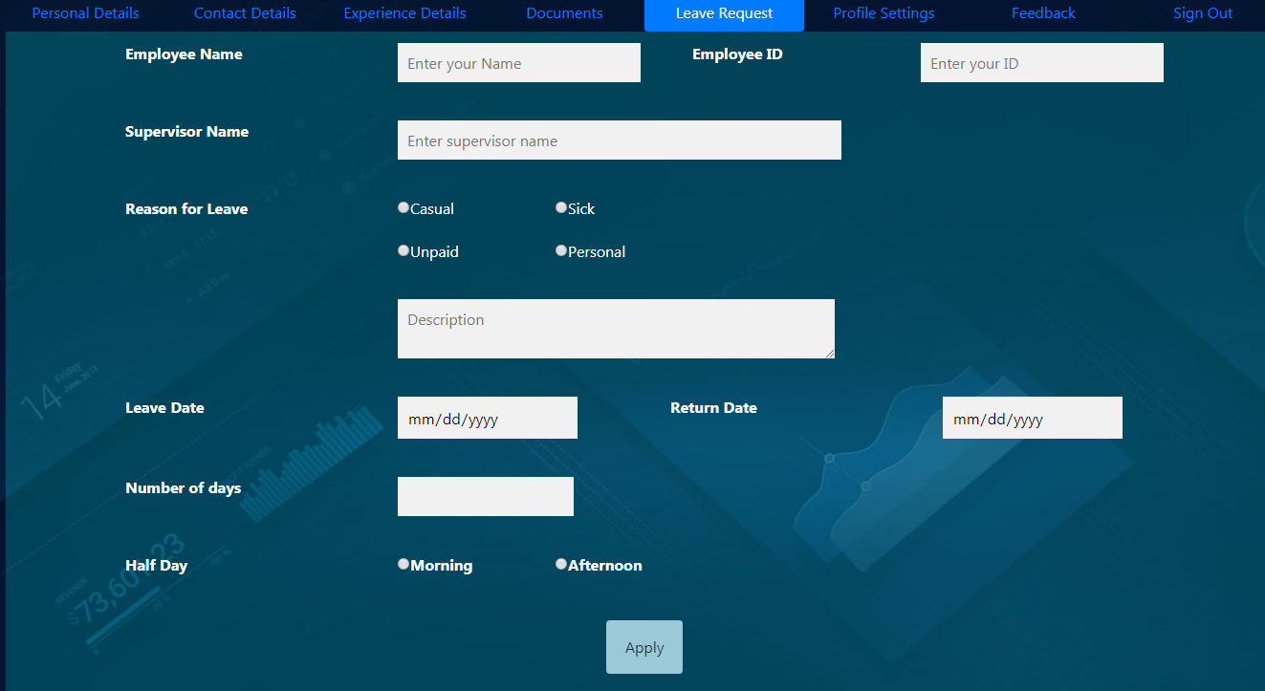

Leave request portal

# Giving feedback for project

This portal is used by project manager to give the feedback employees work on the project. Details given are

* Project name
* Duration
* Feedback
* Position of person who is giving the feedback
* Ratings (out of 5)

# feed.PNG

Feedback portal

As a result of the employee entering the feedback the data will be automatically stored in the database with the confirmation message as shown below.

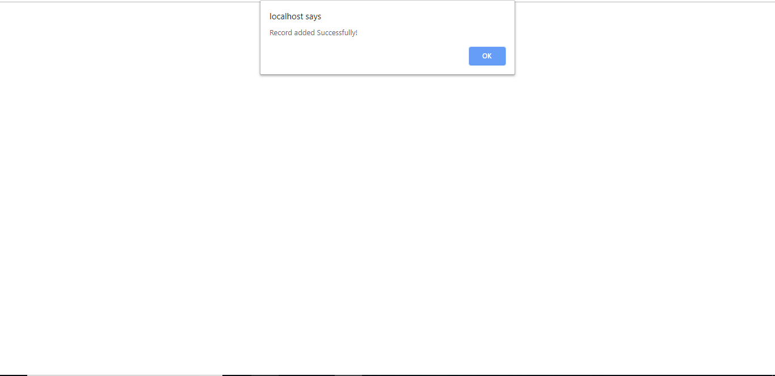

# Calendar with list of holidays

* A calendar with list of holidays is mainly created for displaying the holidays in the organization.
* You can display the list the holidays according to the holidays of an individual organization.
* You can upload the list holiday from your local computer in excel sheet format
* We have used the PHP-ExcelReader to display that sheet in your website.

**Main calendar**

* In main calendar we have used Jquery scripting language to produce the calendar and CSS to produce visual effects.
* The Jquery contains an inbuilt function called as datepicker() to display the calendar.

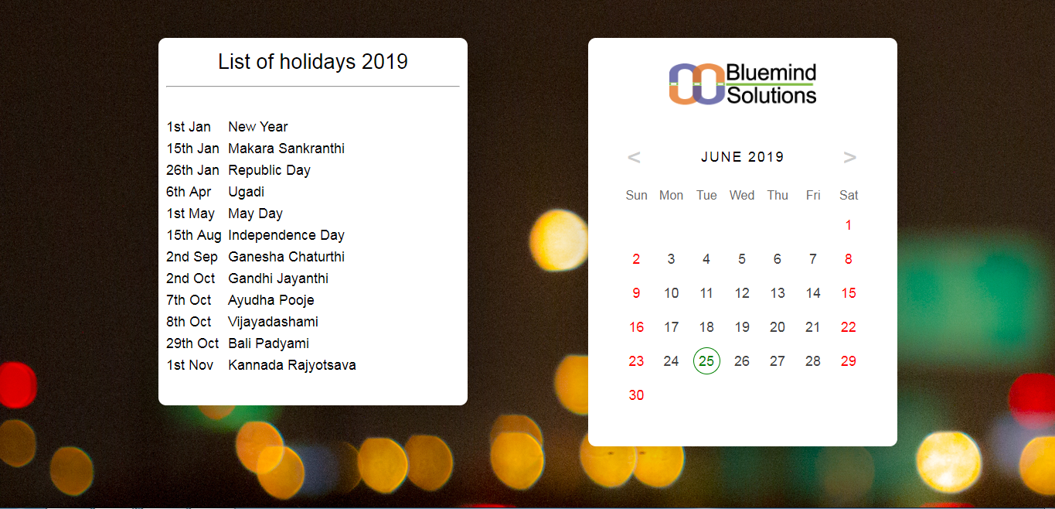

Overview of main calendar

# DAILY WORK SUBMISSION

To submit the daily works, click on the tab “Work Submission”.

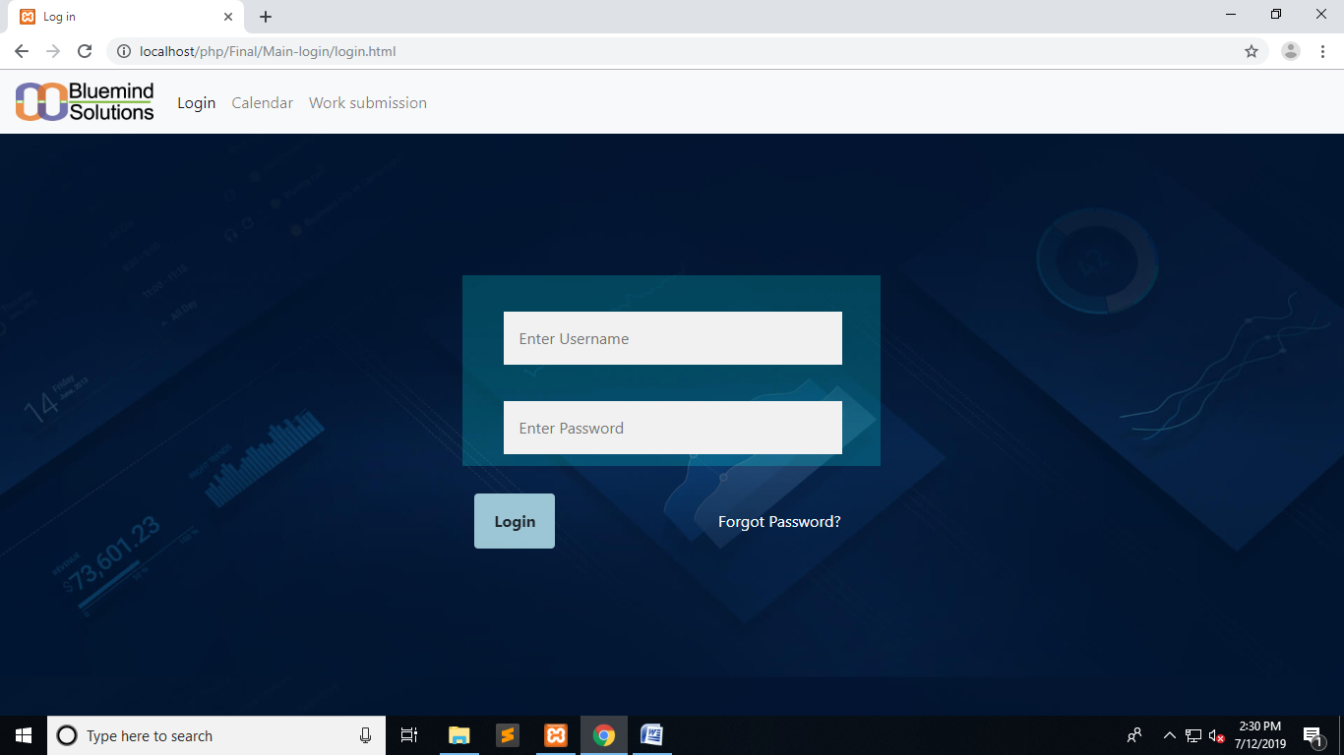

A new web page opens which asks for employee to enter employee ID to submit the work for that particular employee

The web page displays as shown:

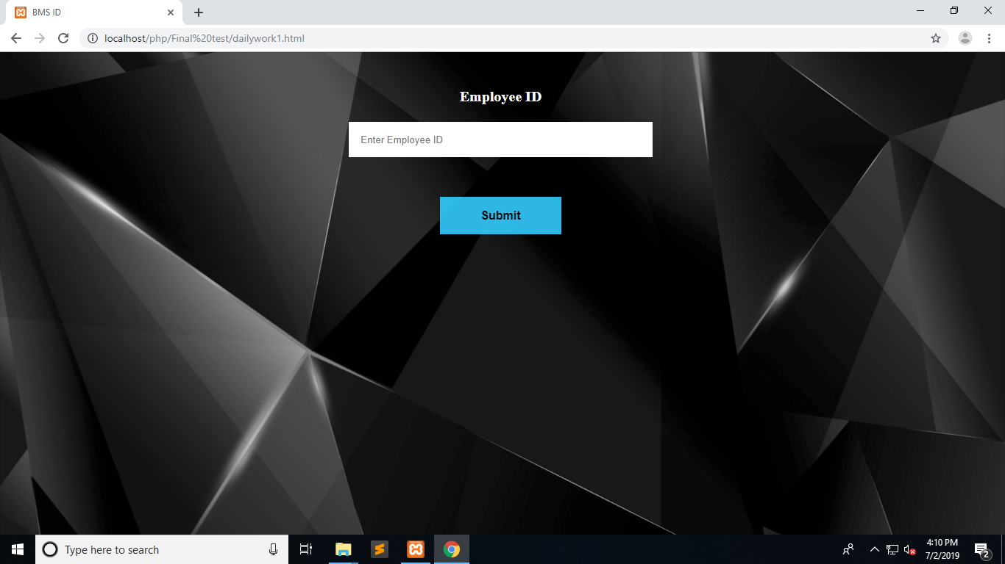

After entering the employee ID; when the submit button is pressed, a new web page opens asking for the work details

The web page displays as shown:

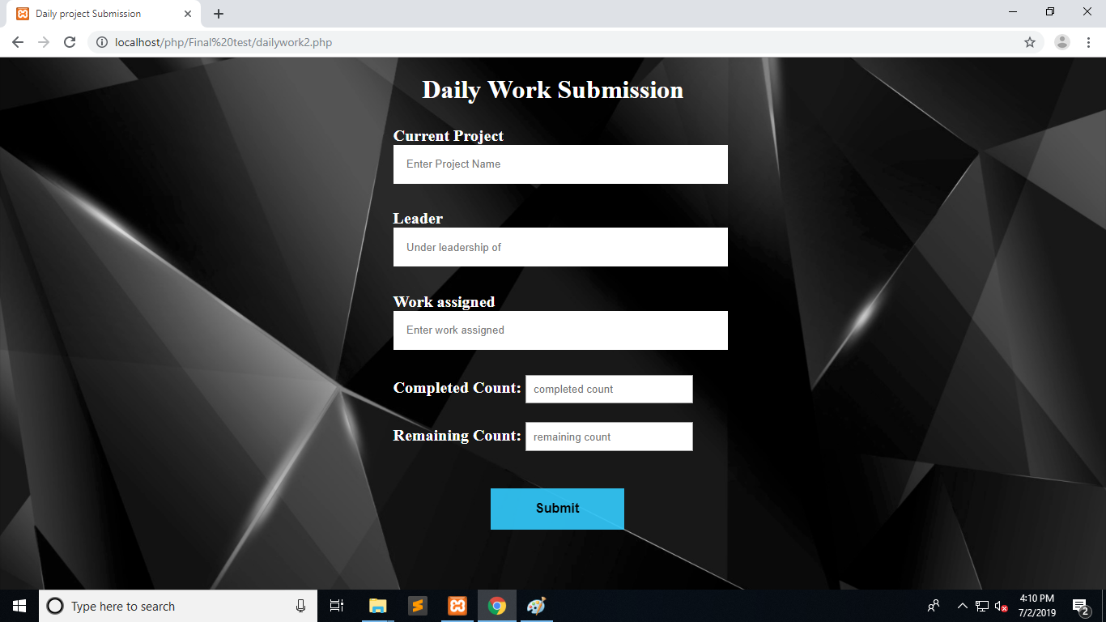

In this web page the employee has to enter certain details like, name of the current project, name of the leader under whom the employee is working, work assigned, completed and remaining count.

When the submit button is pressed, the web page displays “Data Added Successfully”

If the employee wants to enter another data, he/she can choose submit again button, else logout button.

The web page will be displayed as shown:

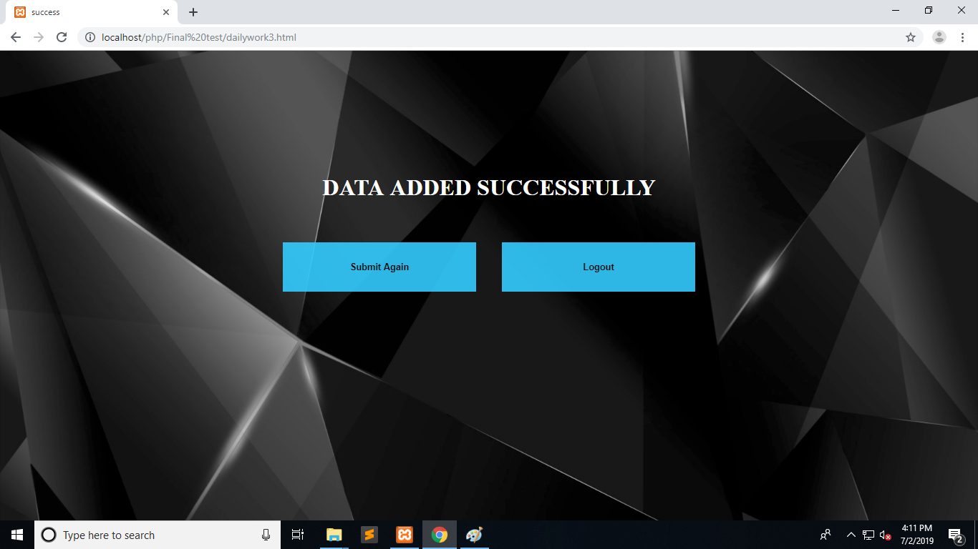

The data will be added to the database.

# Project Statistics

This page mainly consists of 3 tables with one input table and 2 of them showing the result i.e. statistics.

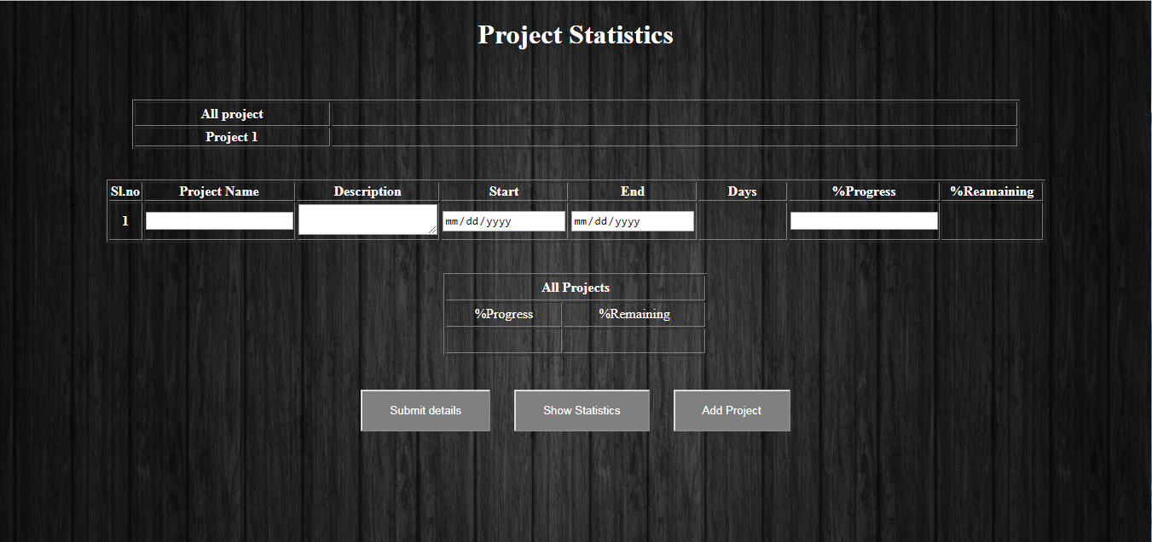

Input Table

This table contains 8 columns namely SI.no, project name, Description, start and end date, days, %progress and remaining progress.

Result Table

The result table shows the details about all the projects and the percentage of their completion in graph.

The third table contains the percentage of progress and the remaining progress

It contains Submit button, statistics button and a button to add another project.

The “Add Project” button allows you to add the number of projects.

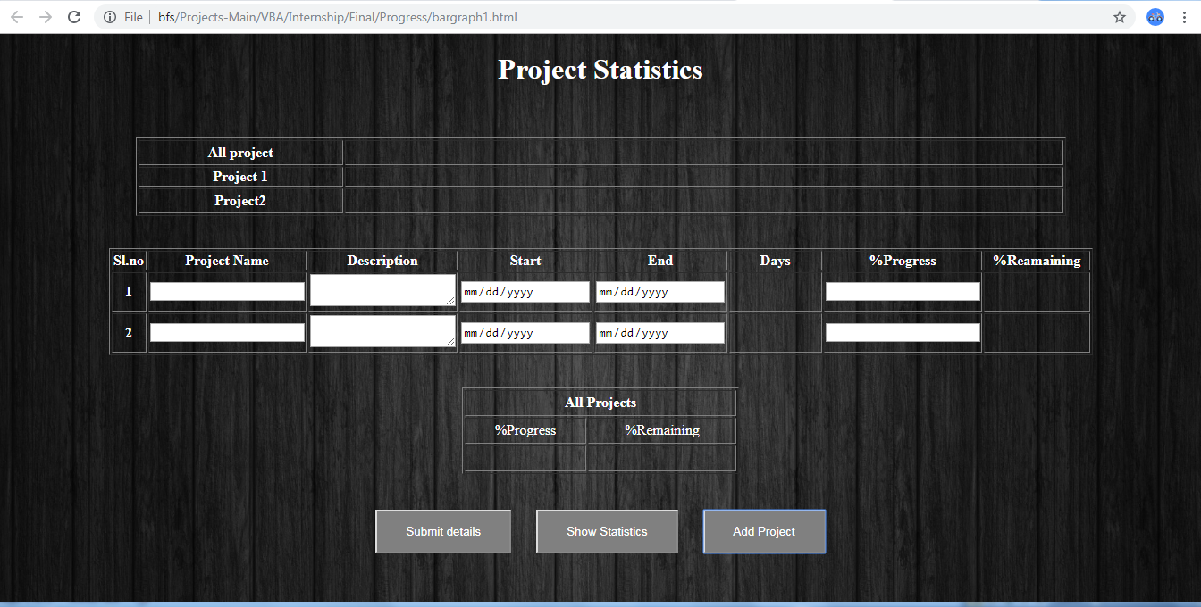

“Show Statistics” button displays the percentage of project completed and the remaining percentage in the form of a bar graph as shown below.

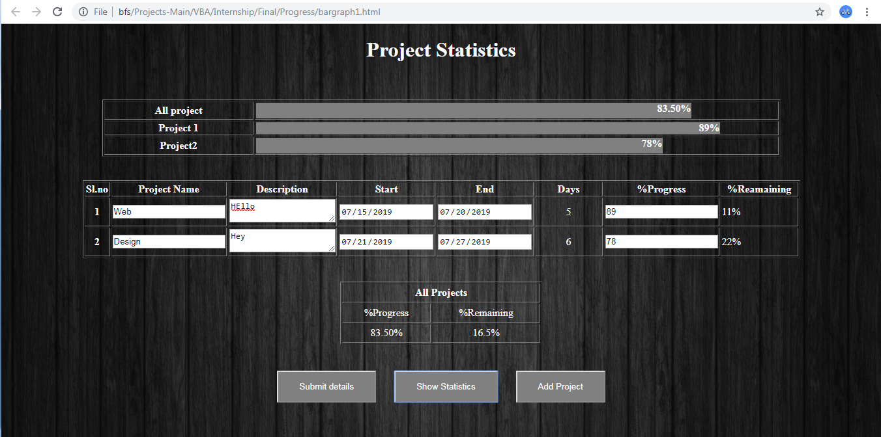

As the completion of the project details are done, the submit button allows the code to store the input details into the database which in turn leads to the next page showing.

